13. ReactJS-HOL
Creating React App : npx create-react-app bloggerapp
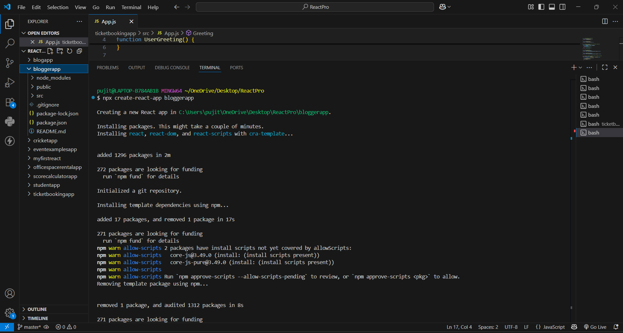
data.js :
export const courses = [
{ id: 1, name: 'Angular', date: '4/5/2021' },
{ id: 2, name: 'React', date: '6/3/2021' }
];

export const books = [
{ id: 101, bname: 'Master React', price: 670 },
{ id: 102, bname: 'Deep Dive into Angular 11', price: 800 },
{ id: 103, bname: 'Mongo Essentials', price: 450 }
];

export const blogs = [
{ id: 201, title: 'React Learning', author: 'Stephen Biz', desc: 'Welcome to learning React!' },
{ id: 202, title: 'Installation', author: 'Schewzdenier', desc: 'You can install React from npm.' }
];
App.css :
.container {
display: flex;
justify-content: space-around;
padding: 40px;
font-family: sans-serif;
text-align: center;
}

.column {
flex: 1;
padding: 0 20px;
}

.border-left {
border-left: 5px solid green;
}

ul {
list-style-type: none;
padding: 0;
}

h1 {
font-size: 2rem;
margin-bottom: 25px;
}

h3 {
font-weight: bold;
margin-bottom: 4px;
}

p {
color: #555;
}
App.js :
import React from 'react';
import { courses, books, blogs } from './data';
import './App.css';

export default function App() {
// 1. Element variable for Course Details using map()
const coursedet = (
<div>
{courses.map((course) => (
<div key={course.id} style={{ marginBottom: '20px' }}>
<h2>{course.name}</h2>
<p>{course.date}</p>
</div>
))}
</div>
);

// 2. Element variable for Book Details using map()
const bookdet = (
<div>
{books.map((book) => (
<div key={book.id} style={{ marginBottom: '20px' }}>
<h3>{book.bname}</h3>
<p>{book.price}</p>
</div>
))}
</div>
);

// 3. Element variable for Blog Details using map()
const content = (
<div>
{blogs.map((blog) => (
<div key={blog.id} style={{ marginBottom: '20px' }}>
<h2>{blog.title}</h2>
<h4>{blog.author}</h4>
<p>{blog.desc}</p>
</div>
))}
</div>
);

return (
<div className="container">
{/* Course Details Section */}
<div className="column">
<h1>Course Details</h1>
{coursedet}
</div>

{/* Book Details Section */}
<div className="column border-left">
<h1>Book Details</h1>
{bookdet}
</div>

{/* Blog Details Section */}
<div className="column border-left">
<h1>Blog Details</h1>
{content}
</div>
</div>
);
}

Running on localhost 3000 :
